Introduction: Every day you react to the huge amount of stimuli that bombards your senses. Sight, smell, hearing, taste, and touch communicate the wonders of the world and make the body respond. These reactions allow us to complete our everyday activities, but the speed at which our nervous system reacts also allows humans to complete amazing tasks. Race car drivers navigate safely past opponents at 200 mph. Baseball players make contact with lightning-quick fastballs. Bullfighters twist out of the way of a charging beast. Think about the sequence of events that must occur to manage events that seem to pass with the blink of an eye.

Intro Question 1) What stimuli does your react to in our everyday world? _________________________

_____________________________________________________________________________________

_____________________________________________________________________________________

Intro Question 2) What part of your nervous system is affected when you holding a bat and trying to hit a baseball/softball during a ball game? Or What part of your nervous system is affected when you holding a basketball trying to make a free throw? _____________________________________________________________________________________

_____________________________________________________________________________________

_____________________________________________________________________________________
In the 1800s, scientist Franciscus Donders set out to measure the “speed of thought.” Using a bulky timing device called a Hipp chronoscope (remember, there were no stopwatches or computers), Donders measured how long it took people to react to and complete particular tasks. He then went on to relate the difficulty of the task and the reaction time to what may be happening in the human brain. Modern day psychologists continue to study the link between this “thinking time” and processing in the nervous system. Neuroscientists use sophisticated imaging techniques to look inside the brain as it does its work. Modern technology has expanded the way in which we can peek into the workings of the brain, but the early work of Donders set the stage for really thinking about thinking.

Intro Question 3) What did scientist Franciscus Donders make? _________________________________

Intro Question 4) What was the experiment supposed to measure? ______________________________

_____________________________________________________________________________________

Intro Question 5) What does a neuroscientist do? ____________________________________________

_____________________________________________________________________________________
Most actions, except for the simplest reflexes, require a large amount of brain activity. The brain receives and processes input, interprets this information, and controls muscle movements to produce a response. The time it takes to complete this sequence of events is called reaction time. In theory, the more complex the task, the more processing time required to react. Let’s see if this holds true.

Essential Question: What does your reaction time mean? ______________________________________
In this project you will test and compare your reaction time to four different tasks, modern day versions of Donders’ experiments. Each task requires different levels of nervous system input that may affect reaction time. With your partner you will then design and execute your own experiment looking at a factor associated with reaction time.

Procedure: Complete the Fastball Reaction Time activity found at the Exploratorium site http://www.exploratorium.edu/baseball/reactiontime.html. In your laboratory journal, record your time for 10 trials. Circle your best time.

Discuss the results with the class. Brainstorm the factors that impact reaction time to simple tasks.

Open the Bryn Mawr College Serendip activity Time to Think? available at http://serendip.brynmawr.edu/bb/reaction/reaction.html. Read the instructions and if necessary, download the Shockwave plug-in. NOTE: All screenshots in this document are taken from the Bryn Mawr website.
Note that four tasks are listed. You will collect data for each of the four tasks (labeled cases). 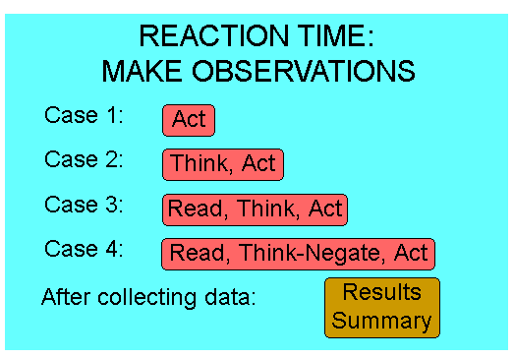
Click on Case 1 – Act. Follow the instructions on the screen to complete the simple reaction task and collect data. You should collect data for 10 trials. The computer will store your recent times in milliseconds and prompt you to try again. Click on Do Another Trial? until you have recorded 10 times. When you have completed 10 trials, click Done.

Trial 1: __________ Trial 2: __________ Trial 3: __________

Trial 4: __________ Trial 5: __________ Trial 6: __________

Trial 7: __________ Trial 8: __________ Trial 9: __________

Trial 10: _________
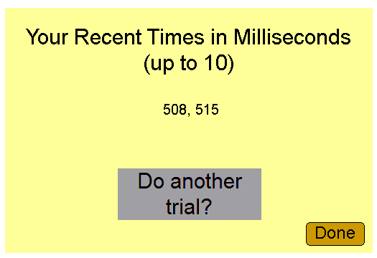
Record the average reaction time for Task 1 in the above Trials # 1-10.
Return to the main menu and click on Case 2 – Think, Act. Follow the instructions on the screen to complete the task and collect data. Note that you will now test your reaction to a discrimination task. In this type of task, you must make a decision before you register a response. REPEAT STEPS # 1-5 again.
Trial 1: __________ Trial 2: __________ Trial 3: __________

Trial 4: __________ Trial 5: __________ Trial 6: __________

Trial 7: __________ Trial 8: __________ Trial 9: __________

Trial 10: _________

Record the average reaction time for Task 2 in the above Trials # 1-10.

Return to the main menu and click on Case 3 – Read, Think, Act. Follow the instructions on the screen to complete the discrimination task and collect data. You should collect data for 10 trials. The computer will store your recent times in milliseconds and prompt you to try again. REPEAT STEPS # 1-5 again.
Trial 1: __________ Trial 2: __________ Trial 3: __________

Trial 4: __________ Trial 5: __________ Trial 6: __________

Trial 7: __________ Trial 8: __________ Trial 9: __________

Trial 10: _________

Record the average reaction time for Task 3 in the above Trials # 1-10.
Record the average reaction time for Task 4 in the above Final Statistics Column.
Return to the main menu and click on Results Summary. Print the screen or copy the statistics box into your laboratory journal.
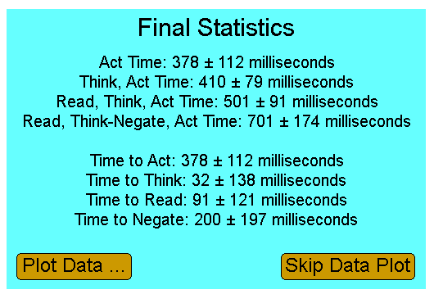
Final Statistics
Act Time: _______________________________________________

Think, Act Time: __________________________________________

Read, Think, Act Time: __________________________________________
Read. Think-Negate, Act Time: __________________________________________
Time to Act: ____________________ Time to Think: _______________________

Time to Read: _______________________ Time to Negate: ______________________

Make sure that your numbers recorded on the above lines at the end of the experiment.

Discuss your results with a partner. Think about how each time relates to cognitive processing and brain function.
Finish Conclusion Questions # 1-5

Conclusion Questions:
- Describe any trends in your simple reaction data – either in the fastball simulation or Task 1. What factors may have attributed to the variation you see over the ten trials?
_____________________________________________________________________________________

_____________________________________________________________________________________

_____________________________________________________________________________________

- Compare your reaction time for Task 2 and Task 3 and for Task 3 and Task 4. Explain your results.
_____________________________________________________________________________________

_____________________________________________________________________________________

_____________________________________________________________________________________

- In terms of processing in the nervous system, explain why your reaction time was most likely faster for the simple reaction task than for any of the discrimination tasks.
_____________________________________________________________________________________

_____________________________________________________________________________________

_____________________________________________________________________________________

- On which task did you seem to make the most mistakes? Discuss why this task was more difficult than the others.
_____________________________________________________________________________________

_____________________________________________________________________________________

_____________________________________________________________________________________

- Were there any noticeable differences in reaction times between you and your partner? What about across gender like males and femals? If so, what might account for this difference?
_____________________________________________________________________________________

_____________________________________________________________________________________

_____________________________________________________________________________________

